SIMATS ENGINEERING
ASSESSMENT TOOL 2
NAME: Danuspriyaa
REG NO: 192411182
COURSE NAME: INTERNET PROGRAMMING
COURSE CODE: CSA43

COURSE OUTCOME COVERED
CO -2 : Apply CSS layout and styling techniques to create visually appealing and
responsive web interfaces, and use JavaScript to enable interactive client-side behavior.
(L3)
Assessment Tool : Design Task
Weightage: 20%

QUESTIONS: Total Marks: 20

Question 1: Responsive Navigation Bar Design - Marks(4)
Suppose that an e-commerce website requires a responsive navigation bar that adapts across
desktop, tablet, and mobile devices.
(a) Identify key components required in a navigation bar for an e-commerce website.
(b) Design a responsive navigation bar using appropriate CSS techniques.
(c) Demonstrate how the navigation adapts to smaller screens (e.g., hamburger menu).
(d) Evaluate the usability and suggest improvements for better user experience.

<!DOCTYPE html>
<html lang="en">
<head>
<meta charset="UTF-8">
<meta name="viewport" content="width=device-width, initial-scale=1.0">
<title>Responsive Navigation Bar</title>

<style>

*{
margin:0;
padding:0;
box-sizing:border-box;
font-family:Arial, sans-serif;
}

body{
background:#f4f4f4;
}

.navbar{
background:#333;
color:white;
display:flex;
justify-content:space-between;
align-items:center;
padding:15px 20px;
}

.logo{
font-size:24px;
font-weight:bold;
}

.menu{
display:flex;
}

.menu a{
color:white;
text-decoration:none;
padding:10px 15px;
}

.menu a:hover{
background:#555;
border-radius:5px;
}

.icon{
display:none;
font-size:28px;
cursor:pointer;
}

/* Mobile View */
@media(max-width:768px){

.menu{
display:none;
flex-direction:column;
width:100%;
background:#333;
position:absolute;
top:60px;
left:0;
}

.menu.show{
display:flex;
}

.menu a{
padding:15px;
border-top:1px solid #555;
}

.icon{
display:block;
}

}

</style>
</head>

<body>

<nav class="navbar">

<div class="logo">ShopEasy</div>

<div class="menu" id="menu">
<a href="#">Home</a>
<a href="#">Products</a>
<a href="#">Categories</a>
<a href="#">Cart</a>
<a href="#">Login</a>
</div>

<div class="icon" onclick="toggleMenu()">☰</div>

</nav>

<script>

function toggleMenu(){
document.getElementById("menu").classList.toggle("show");
}

</script>

</body>
</html>
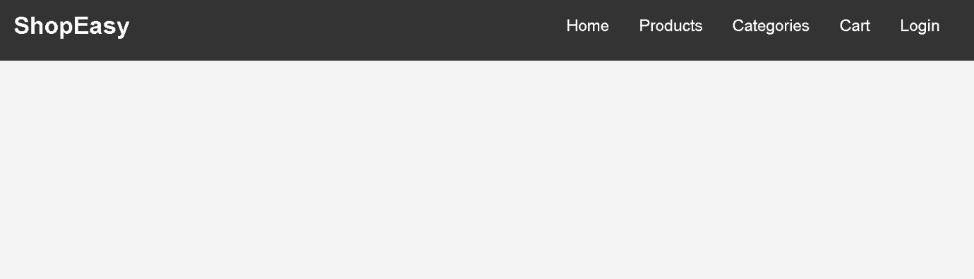

Question 2: Product Hover Effect - Marks(4)
Suppose that an e-commerce website wants to enhance user interaction through visual effects
on product items.
(a) Identify suitable CSS properties for hover effects.
(b) Suggest appropriate CSS animation or transition for product interaction.
(c) Design a hover effect for a product card.
(d) Evaluate performance and user experience considerations.
<!DOCTYPE html>
<html lang="en">
<head>
<meta charset="UTF-8">
<meta name="viewport" content="width=device-width, initial-scale=1.0">
<title>Product Hover Effect</title>

<style>

*{
margin:0;
padding:0;
box-sizing:border-box;
font-family:Arial, sans-serif;
}

body{
background:#f4f4f4;
display:flex;
justify-content:center;
align-items:center;
height:100vh;
}

.card{
width:250px;
background:white;
border-radius:10px;
overflow:hidden;
text-align:center;
box-shadow:0 4px 8px rgba(0,0,0,0.2);
transition:0.3s;
}

.card img{
width:100%;
height:200px;
}

.card h2{
margin:15px 0;
}

.card p{
color:green;
font-size:20px;
margin-bottom:15px;
}

.card button{
margin-bottom:20px;
padding:10px 20px;
background:#007bff;
color:white;
border:none;
border-radius:5px;
cursor:pointer;
}

.card:hover{
transform:scale(1.05);
box-shadow:0 8px 20px rgba(0,0,0,0.4);
}

.card button:hover{
background:#0056b3;
}

</style>
</head>

<body>

<div class="card">
<img src="https://via.placeholder.com/250x200" alt="Product">
<h2>Wireless Headphones</h2>
<p>$49.99</p>
<button>Buy Now</button>
</div>

</body>
</html>
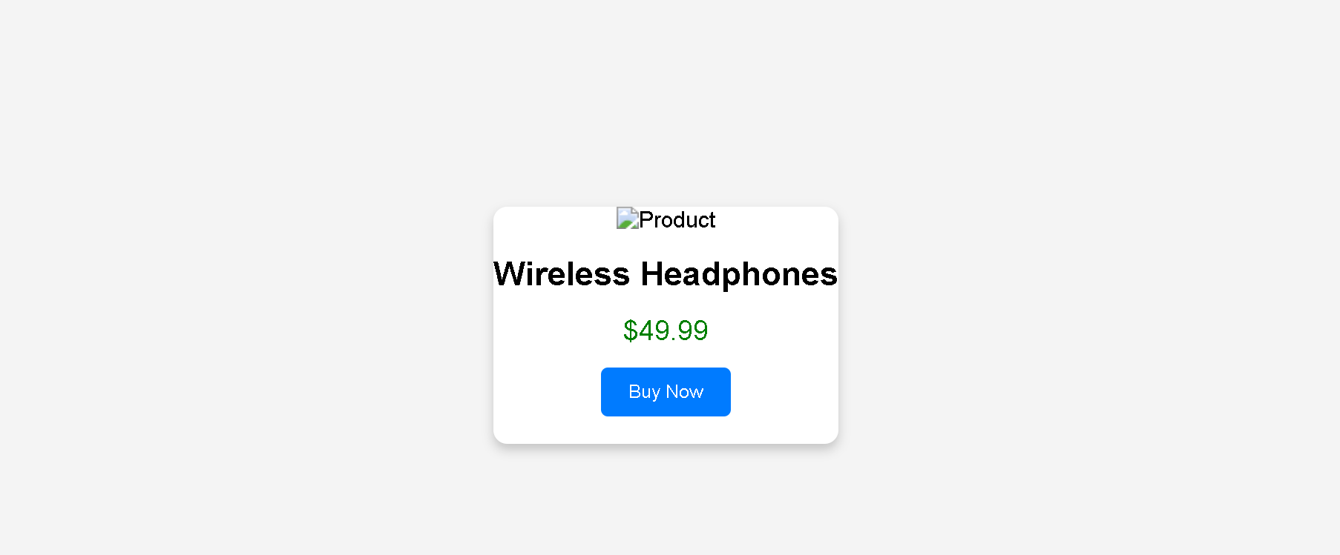

Question 3: Layout Selection (Flexbox vs Grid) - Marks(4)
Suppose that a dashboard layout needs to be designed for a web application.
(a) Identify layout requirements of a dashboard (rows, columns, alignment).
(b) Compare Flexbox and Grid based on layout needs.
(c) Choose the most suitable layout technique and justify your choice.
(d) Evaluate the scalability and responsiveness of the chosen approach.
<!DOCTYPE html>
<html lang="en">
<head>
<meta charset="UTF-8">
<meta name="viewport" content="width=device-width, initial-scale=1.0">
<title>Dashboard Layout Using CSS Grid</title>

<style>

*{
margin:0;
padding:0;
box-sizing:border-box;
font-family:Arial, sans-serif;
}

body{
background:#f4f4f4;
}

.container{
display:grid;
grid-template-columns:220px 1fr;
grid-template-rows:70px auto 60px;
grid-template-areas:
"header header"
"sidebar main"
"footer footer";
gap:10px;
height:100vh;
padding:10px;
}

.header{
grid-area:header;
background:#007bff;
color:white;
display:flex;
justify-content:center;
align-items:center;
font-size:24px;
}

.sidebar{
grid-area:sidebar;
background:#333;
color:white;
padding:20px;
}

.sidebar ul{
list-style:none;
}

.sidebar li{
margin:15px 0;
}

.main{
grid-area:main;
background:white;
padding:20px;
}

.cards{
display:grid;
grid-template-columns:repeat(3,1fr);
gap:15px;
margin-top:20px;
}

.card{
background:#e3f2fd;
padding:30px;
text-align:center;
border-radius:8px;
}

.footer{
grid-area:footer;
background:#007bff;
color:white;
display:flex;
justify-content:center;
align-items:center;
}

@media(max-width:768px){

.container{
grid-template-columns:1fr;
grid-template-areas:
"header"
"sidebar"
"main"
"footer";
}

.cards{
grid-template-columns:1fr;
}

}

</style>

</head>

<body>

<div class="container">

<div class="header">
Dashboard
</div>

<div class="sidebar">
<h3>Menu</h3>
<ul>
<li>Home</li>
<li>Users</li>
<li>Reports</li>
<li>Settings</li>
</ul>
</div>

<div class="main">
<h2>Welcome</h2>
<p>This is the dashboard content.</p>

<div class="cards">
<div class="card">Card 1</div>
<div class="card">Card 2</div>
<div class="card">Card 3</div>
</div>

</div>

<div class="footer">
Copyright © 2026
</div>

</div>

</body>
</html>
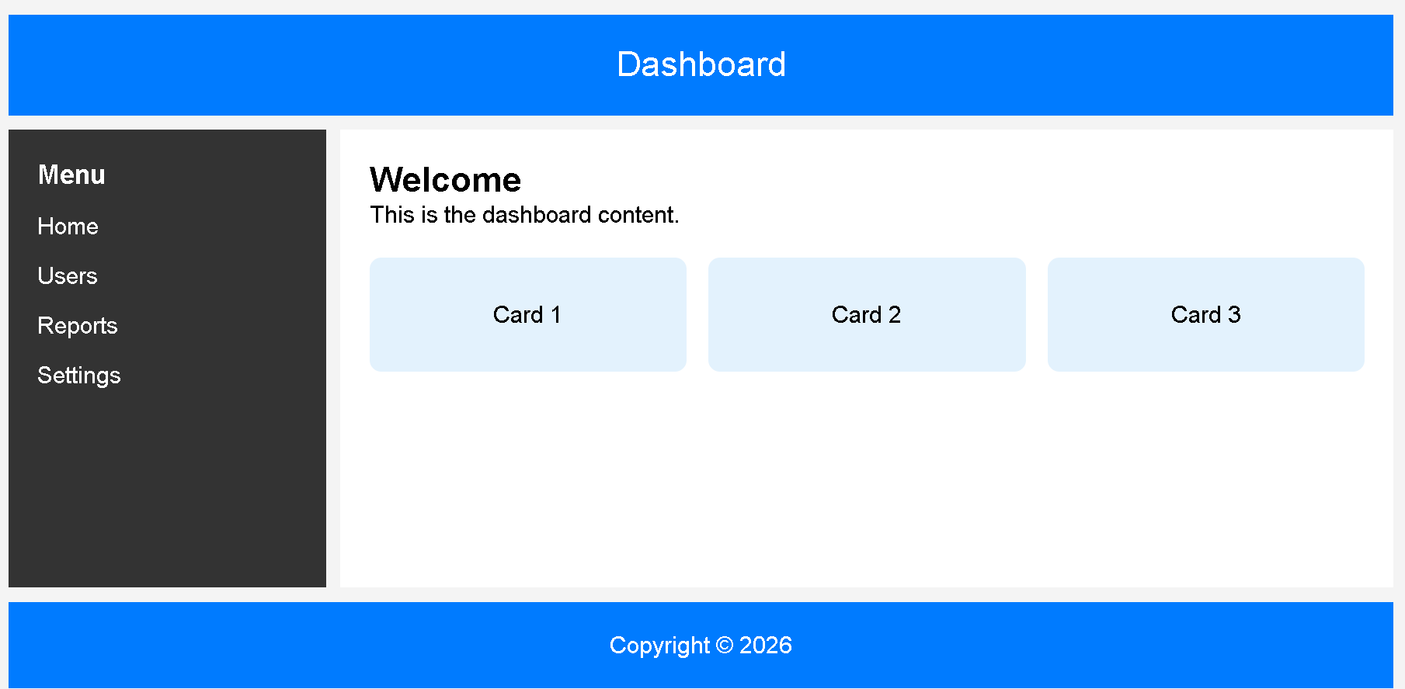

Question 4: Mobile-First Blog Layout - Marks(4)
Suppose that a blog page must be designed following a mobile-first approach.
(a) Identify key sections of a blog layout.
(b) Design a mobile-first layout using CSS.
(c) Demonstrate how the layout scales for larger screens using media queries.
(d) Evaluate accessibility and readability of the design.
<!DOCTYPE html>
<html lang="en">
<head>
<meta charset="UTF-8">
<meta name="viewport" content="width=device-width, initial-scale=1.0">
<title>Mobile-First Blog Layout</title>

<style>

*{
margin:0;
padding:0;
box-sizing:border-box;
font-family:Arial, sans-serif;
}

body{
background:#f4f4f4;
}

/* Header */
header{
background:#333;
color:white;
text-align:center;
padding:20px;
}

/* Navigation */
nav{
background:#555;
text-align:center;
padding:10px;
}

nav a{
color:white;
text-decoration:none;
margin:10px;
}

/* Mobile First Layout */
.container{
display:flex;
flex-direction:column;
padding:15px;
}

article{
background:white;
padding:20px;
margin-bottom:15px;
border-radius:8px;
}

aside{
background:#dddddd;
padding:20px;
border-radius:8px;
}

footer{
background:#333;
color:white;
text-align:center;
padding:15px;
margin-top:15px;
}

/* Tablet/Desktop View */
@media(min-width:768px){

.container{
flex-direction:row;
gap:20px;
}

article{
flex:3;
}

aside{
flex:1;
}

}

</style>

</head>

<body>

<header>
<h1>My Blog</h1>
</header>

<nav>
<a href="#">Home</a>
<a href="#">Articles</a>
<a href="#">About</a>
<a href="#">Contact</a>
</nav>

<div class="container">

<article>
<h2>Welcome to My Blog</h2>
<p>
This is a simple mobile-first blog page. The article section contains the main content of the blog.
</p>
</article>

<aside>
<h3>Recent Posts</h3>
<ul>
<li>HTML Basics</li>
<li>CSS Grid</li>
<li>JavaScript Events</li>
</ul>
</aside>

</div>

<footer>
<p>© 2026 My Blog. All Rights Reserved.</p>
</footer>

</body>
</html>
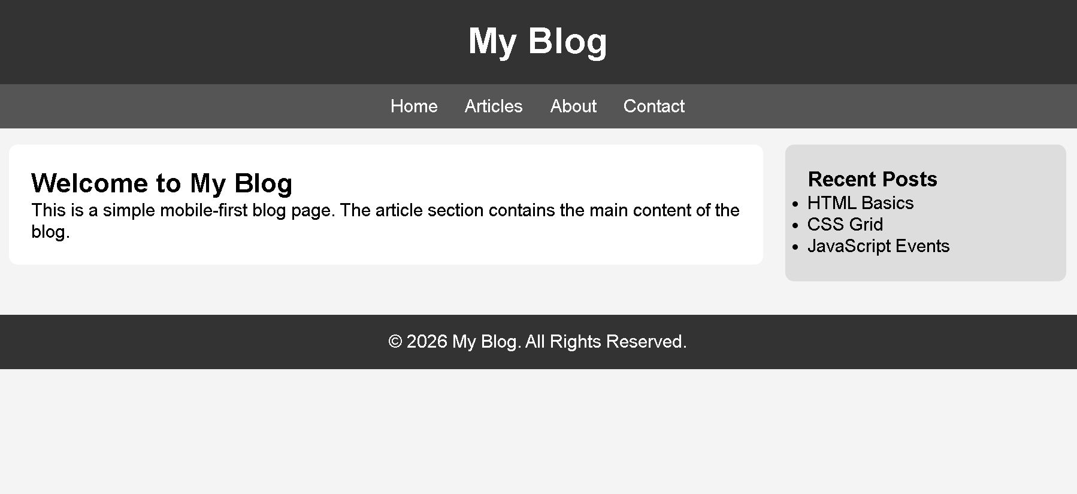

Question 5: JavaScript Event Handling for Dynamic Menu - Marks(4)
Suppose that a website includes a dynamic menu that responds to user interactions.
(a) Identify appropriate JavaScript events for menu interaction.
(b) Design event handling logic for menu toggle functionality.
(c) Implement interaction for user actions (click/hover).
(d) Evaluate performance and suggest improvements.
<!DOCTYPE html>
<html lang="en">
<head>
<meta charset="UTF-8">
<meta name="viewport" content="width=device-width, initial-scale=1.0">
<title>Dynamic Menu</title>

<style>

*{
margin:0;
padding:0;
box-sizing:border-box;
font-family:Arial, sans-serif;
}

body{
background:#f4f4f4;
text-align:center;
padding:50px;
}

button{
padding:12px 25px;
font-size:18px;
background:#007bff;
color:white;
border:none;
border-radius:5px;
cursor:pointer;
}

button:hover{
background:#0056b3;
}

#menu{
display:none;
width:200px;
margin:20px auto;
background:white;
border:1px solid #ccc;
border-radius:5px;
box-shadow:0 4px 8px rgba(0,0,0,0.2);
}

#menu a{
display:block;
padding:15px;
text-decoration:none;
color:black;
border-bottom:1px solid #ddd;
}

#menu a:hover{
background:#f0f0f0;
}

.show{
display:block;
}

</style>

</head>
<body>

<h2>Dynamic Menu Example</h2>

<button id="menuBtn">☰ Menu</button>

<div id="menu">
<a href="#">Home</a>
<a href="#">Products</a>
<a href="#">Services</a>
<a href="#">Contact</a>
</div>

<script>

let button = document.getElementById("menuBtn");
let menu = document.getElementById("menu");

button.addEventListener("click", function(){
menu.classList.toggle("show");
});

</script>

</body>
</html>
